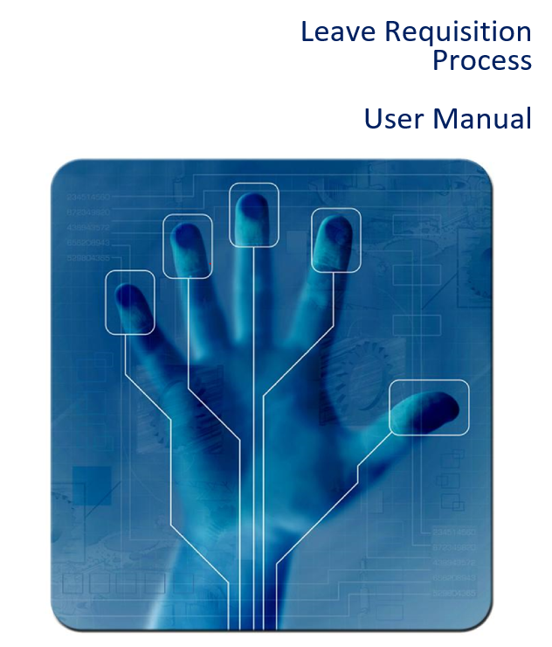
Leave Requisition Process

User Manual

Customer: | [Company]
Title: | Leave Requisition Process
Author: | Daniel Carr
Updated by: | Su-Anne de Jong
Revision: | Final
Date: | 19 June 2019
Priority: | High
Date Required: | 30 June 2019

Not for use or disclosure outside [Company] or FlowCentric Technologies except under written agreement.

Table of Approval/Acceptance
Responsibility | Designation | Name | Signature | Date
Compiled by | Consultant
Checked by | Developer
Process Checked | Process User
Process Sign-off | Process Owner
Project Sign-off | Customer Project Manager
Financial Sign-off | Financial

Assignment Information
Responsibility | Designation | Name | Contact Information
Functional Owner
Technical Owner
Data Owner
Key Contact

Revision History
Revision | Approved | Approval Date | Description
Draft |  |  | Draft for Review
1.0
2.0

Development Status
 | Functional Specifications | Technical Specifications | Program/Process Development | Testing Requirements
Status
Approved by
Date

Document Information
Filename and path | Leave Requisition Process User Manual v1.0.docx
Date Created | 19 June 2019
Date Updated | 16 July 2019
Last Printed | 19 June 2019

Introduction

Purpose of this Document
The purpose of this document is to outline the training guide for the Leave Requisition Process for [Company].

Scope of this Document
The scope of this document is limited to the Leave Requisition Process test plan as was discussed with [Company] and is not intended to support any other functions that [Company] may have.

Terms and Definition

Terms and Abbreviations | Description

Reference Documentation

Document Name | Description

Contents
Table of Approval/Acceptance 2
Assignment Information 2
Revision History 2
Distribution List 2
Completion Dates 2
Development Status 3
Document Information 3
1. Introduction 3
1.1. Purpose of this Document 3
1.2. Scope of this Document 3
1.3. Terms and Definition 3
1.4. Reference Documentation 3
2. Processes from User’s Perspective 6
2.1. Signing On 6
3. Leave Requisition Process 7
3.1. Scenario 1 7
3.1.1. Fill in a Leave Form 7
3.1.2. Approve Leave 8
3.1.3. Update HR System 10
3.2. Scenario 2 11
3.2.1. Fill in Leave on Behalf of Somebody Else 11
3.2.2. Approve Leave 13
3.2.3. Update HR System 15

List of Images
Image 1 – Log on Screen 5
Image 2 – Main Screen 5
Image 3 – Fill in a Leave Form 6
Image 4 – Approve Leave 8
Image 5 – Notification (Leave Declined) 9
Image 6 – Update HR System 10
Image 7 – Fill in Leave on Behalf of Somebody Else 11
Image 8 – Approve Leave 12
Image 9 – Notification (Leave Declined) 13
Image 10 – Update HR System 14

Processes from User’s Perspective

Signing On
The sign on screen (Image 1) will allow all users who have access to the [Company] system to sign on by entering a username and password.

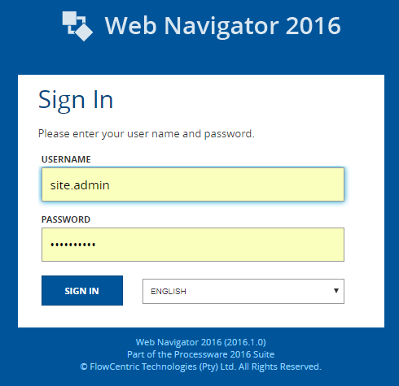
Image 1 – Log on Screen

The steps to log on are as follows: Type in your “Username”
- Type in your “Password”
- Click the “Sign In” button

Once you have successfully signed on, the [Company] main screen will be displayed (Image 2).

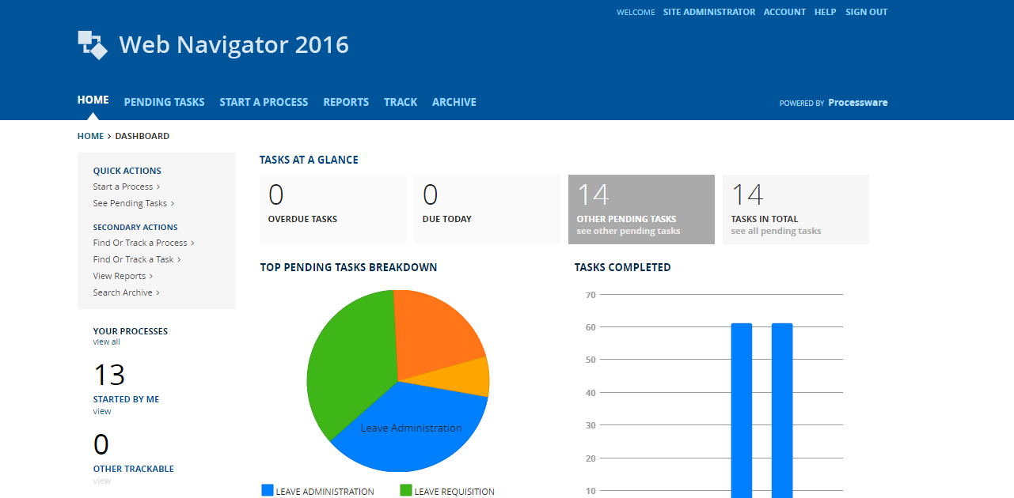
Image 2 – Main Screen

Leave Requisition Process
This section will describe the Leave Requisition process and all the steps taken until the employee’s leave has been approved by the company. Both scenarios will be shown to provide the users with an overview of the different steps to apply for leave.

Scenario 1
This section describes how a user will apply for leave for themselves and HR will approve it and then update the system.

Fill in a Leave Form
This section describes how a user captures their leave on the system.

Roles: Everyone

Any registered employee will log onto the [Company] FlowCentric website and navigate to the Start A Process >> Human Resources >> Leave Requisition >> Fill in a Leave Form menu option and the form will be shown to the employee, as seen in Image 3.

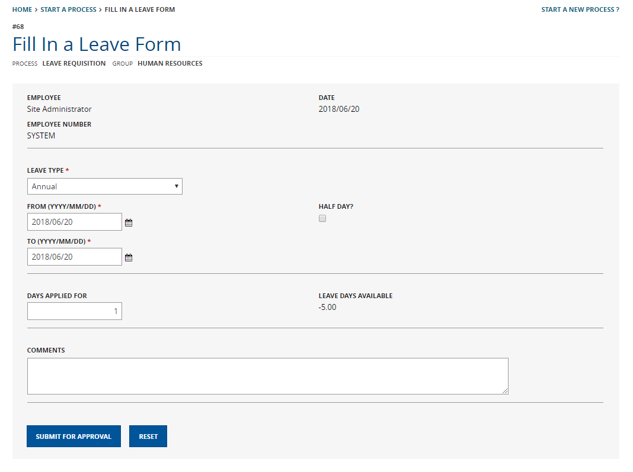
Image 3 – Fill in a Leave Form

The employee will select an option from the “Leave Type” dropdown list. The different options are:
- Annual
- Family Responsibility / Compassionate
- Maternity
- Sick
- Study
- Unpaid (Time Off Without Pay)
- Other

The below objects will be hidden/visible depending on the “Leave Type” selection made:

Leave Type  Note  (Visible) | Leave Type  Note  (Invisible) | Leave Days  Available  (Visible) | Leave Days  Available  (Invisible) | Attach Medical  Certificate (Visible) | Attach Medical  Certificate (Invisible)
Maternity | - Annual  - Family Responsibility  / Compassionate  - Maternity  - Sick  - Study  - Unpaid (Time  Off Without Pay)  - Other | Annual | - Family Responsibility  / Compassionate  - Maternity  - Sick  - Study  - Unpaid (Time  Off Without  Pay)  - Other | Sick | - Annual  - Family Responsibility  / Compassionate  - Maternity  - Sick  - Study  - Unpaid (Time  Off Without  Pay)  - Other

The ‘Leave Type Note’ will use the following wording:

For Paternity Leave please submit a request for Family Responsibility Leave, Maternity Leave is only available to female employees

The “Leave Days Available” Reference Label control will update automatically with the number of days remaining for the employee for that type of leave.

The employee must then select the dates by either typing the dates in the text boxes or selecting from the calendar control that appears. The “Days Applied For” Textbox control will automatically update with the number of days. However, this can be changed if not calculated correctly.

If you are taking a “Half Day” on either of the dates you have selected, then click on the checkbox control next to the date for which you are taking a half day.

Any comments the user wishes to enter can be made or not and the activity is submitted, the next activity triggered is Approve Leave.

Approve Leave
This section describes how the manager who the employee reports to is informed of the leave requested.

Roles: Report To / Manager

The manager that the employee reports to will log onto the [Company] FlowCentric website and navigate to the Pending >> Approve Leave menu option and the form will be shown to the manager, as seen in Image 4.

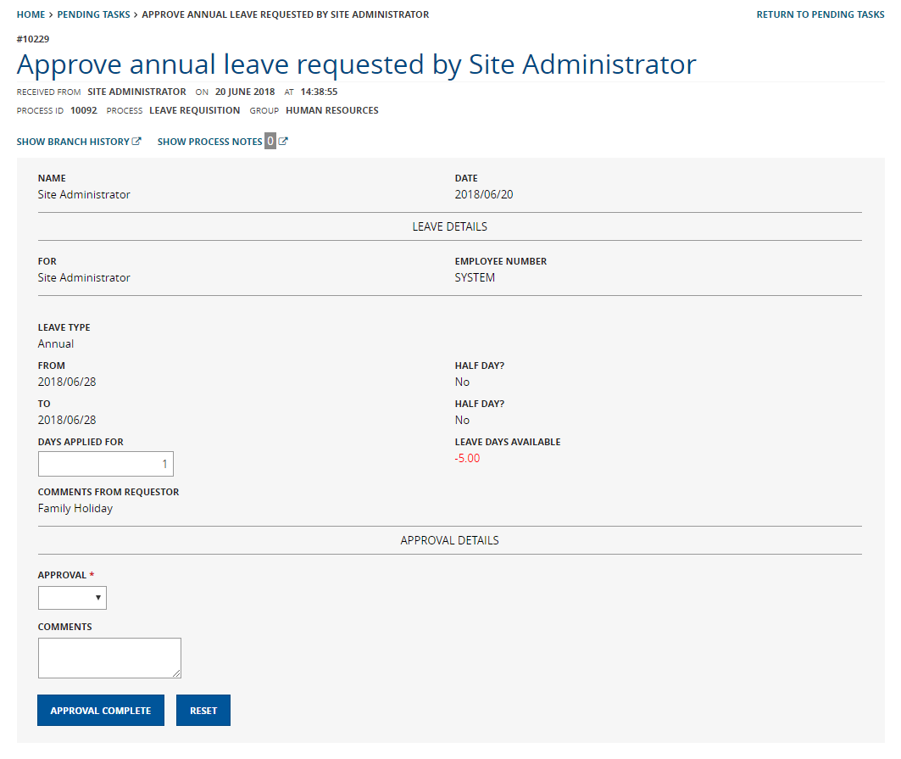
Image 4 – Approve Leave
With reference to the table in 3.1.1 above, display the visible objects per Leave Type.

The manager will receive the Approve Leave notification and must check the information and if the “Days Applied For” is incorrect this can be changed. Once verified the manager must select an option from the “Approval” dropdown list, the options are:

- Approve
- Decline

If “Decline” is selected then “Comments” becomes a required field, otherwise you do not need to enter any comments. Once all the details have been filled in, click the “Approval Complete” button.

If the leave request is declined, then a notification is sent to the originator to advise the employee that the leave was declined which must be acknowledged, as seen in Image 5.

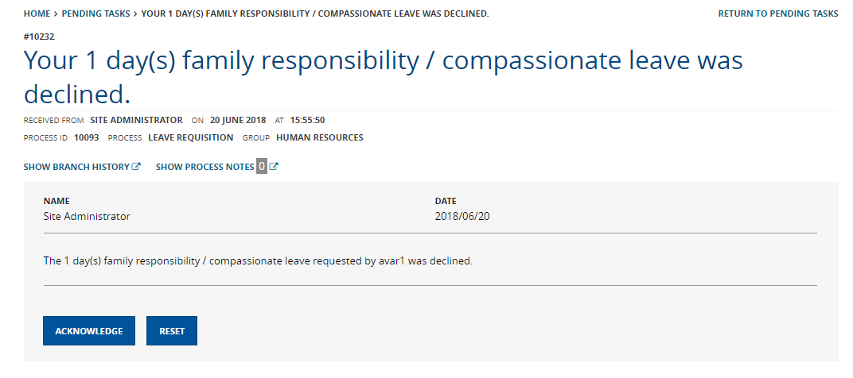
Image 5 – Notification (Leave Declined)

If the leave is approved, then the Update HR System activity is triggered.

Update HR System
This section describes how HR authorizes the update of the HR system for the leave requested.

Roles: HR Department

The HR Clerk will log onto the [Company] FlowCentric website and navigate to the Pending Tasks >> Update HR System menu option and the form will be shown to the user, as seen in Image 6.

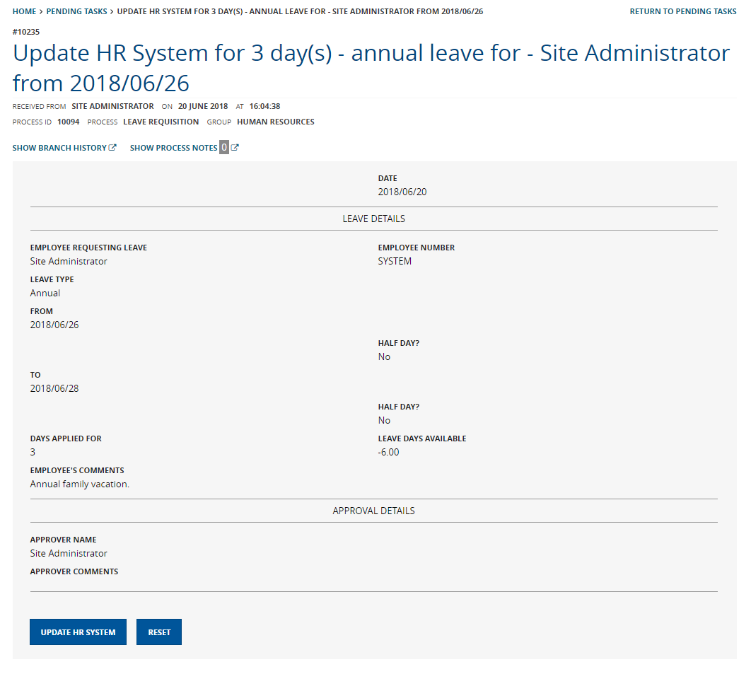
Image 6 – Update HR System

The HR Clerk would use this activity to complete the application and all that is required is to click the “Update HR System” button, and the process will be archived.

Scenario 2
This section describes how a user will apply for leave on behalf of someone else and HR will approve it and then update the system.

Fill in Leave on Behalf of Somebody Else
This section describes how a user captures someone else’s leave on the system.

Roles: Everyone

Any registered employee will log onto the [Company] FlowCentric website and navigate to the Start A Process >> Human Resources >> Leave Requisition >> Fill in Leave on Behalf of Someone Else menu option.

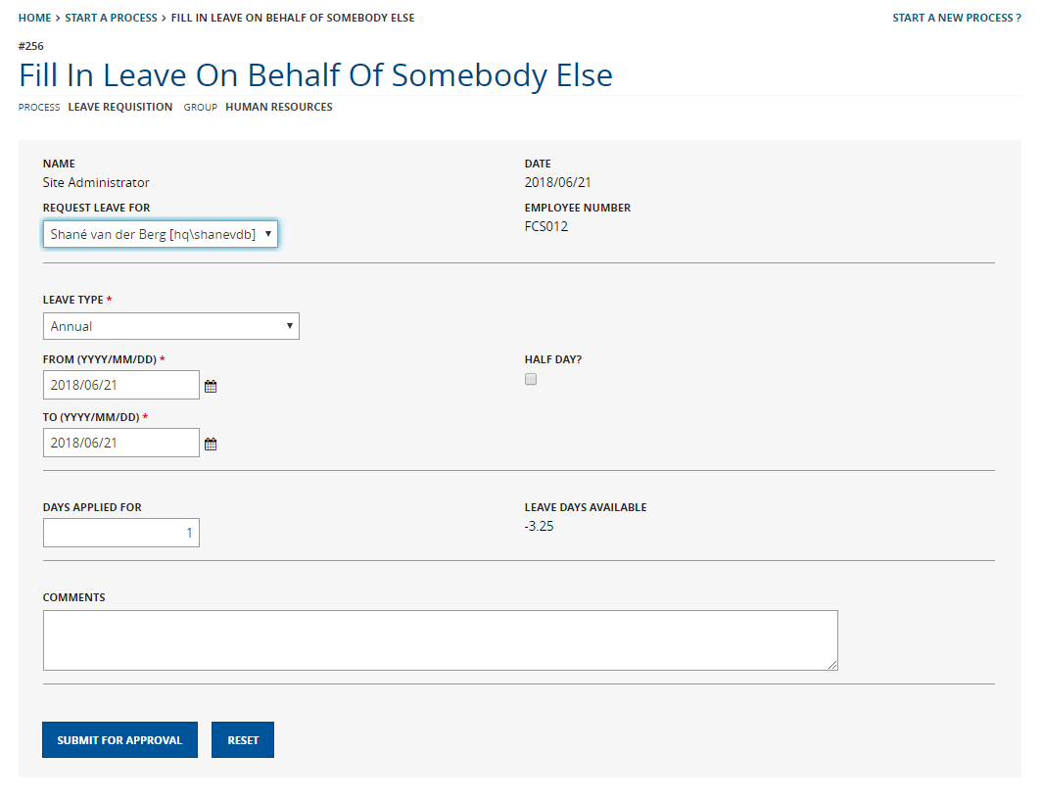
Image 7 – Fill in Leave on Behalf of Somebody Else

Select the name of the employee you wish to apply for leave from the “Request Leave For” dropdown list. This is configured in the Processware tool using the user’s metadata and not the web navigator. Once a name has been selected the rest of the page will load as seen above in Image 7.

The employee will select an option from the “Leave Type” dropdown list. The different options are:
- Annual
- Family Responsibility / Compassionate
- Maternity
- Sick
- Study
- Unpaid (Time Off Without Pay)
- Other

The below objects will be hidden/visible depending on the “Leave Type” selection made:

Leave Type  Note  (Visible) | Leave Type  Note  (Invisible) | Leave Days  Available  (Visible) | Leave Days  Available  (Invisible) | Attach Medical  Certificate (Visible) | Attach Medical  Certificate (Invisible)
Maternity | - Annual  - Family Responsibility  / Compassionate  - Maternity  - Sick  - Study  - Unpaid (Time  Off Without Pay)  - Other | Annual | - Family Responsibility  / Compassionate  - Maternity  - Sick  - Study  - Unpaid (Time  Off Without  Pay)  - Other | Sick | - Annual  - Family Responsibility  / Compassionate  - Maternity  - Sick  - Study  - Unpaid (Time  Off Without  Pay)  - Other

The “Leave Days Available” Reference Label control will update automatically with the number of days remaining for the employee for that type of leave.

The employee must then select the dates by either typing the dates in the text boxes or selecting from the calendar control that appears. The “Days Applied For” Textbox control will automatically update with the number of days. However, this can be changed if not calculated correctly.

If you are taking a “Half Day” on either of the dates you have selected, then click on the checkbox control next to the date for which you are taking a half day.

Any comments the user wishes to enter can be made or not and the activity is submitted, the next activity triggered is Approve Leave.

Approve Leave
This section describes how the manager of the employee the leave was requested for is informed of the leave requested.

Roles: Report To / Manager

The manager will log onto the [Company] FlowCentric website and navigate to the Pending >> Approve Leave menu option and the form will be shown to the employee, as seen in Image 8.

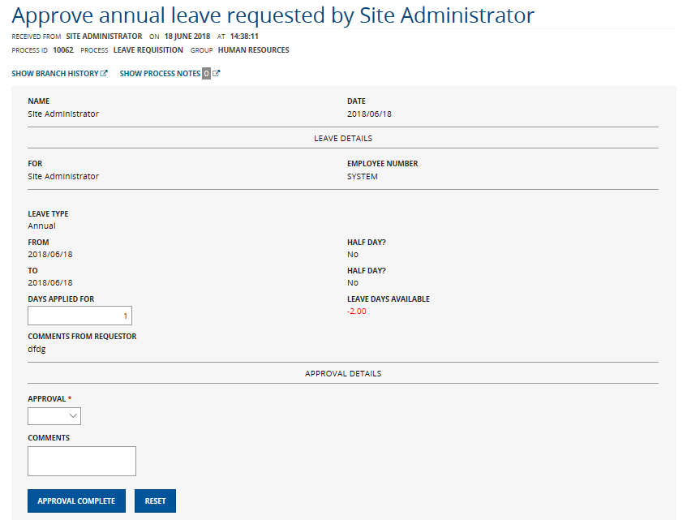
Image 8 – Approve Leave
With reference to the table in 3.2.1 above, display the visible objects per Leave Type.

The manager will receive the Approve Leave notification and must check the information and if the “Days Applied For” is incorrect this can be changed. Once verified the manager must select an option from the “Approval” dropdown list, the options are:

- Approve
- Decline

If “Decline” is selected then “Comments” becomes a required field, otherwise you do not need to enter any comments. Once all the details have been filled in, click the “Approval Complete” button.

If the leave request is declined, then a notification is sent to the originator to advise the employee that the leave was declined which must be acknowledged, as seen in Image 9.

Image 9 – Notification (Leave Declined)

If the leave is approved, then the Update HR System activity is triggered.

Update HR System
This section describes how HR authorizes the update of the HR system for the leave requested.

Roles: HR Department

The HR Clerk will log onto the [Company] FlowCentric website and navigate to the Pending Tasks >> Update HR System menu option and the form will be shown to the employee, as seen in Image 10.

Image 10 – Update HR System

The HR Clerk would use this activity to complete the application and all that is required is to click the “Update HR System” button, and the process will be archived.

